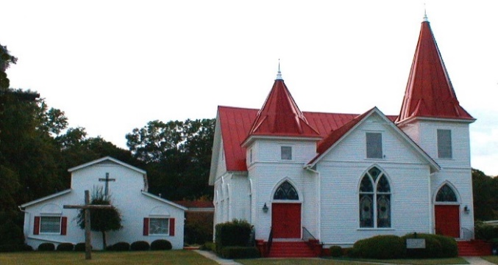 |  APRIL 2021  Please Note! All April activities subject to change depending on Covid-19 virus containment!  Check our webpage often for updates at www.mzsl.org
Sun. | Mon. | Tue. | Wed. | Thu. | Fri. | Sat.
 |  |  |  | 1 Maundy Thursday Online Service 6:00 p.m. | 2 Good Friday Online Service 6:00 p.m. | 3
 |  |  |  |  | A J Collier | Emma Felker
4 Easter Sunday | 5 | 6 | 7 | 8 | 9 | 10
Joint Sunrise Service  Oglethorpe Cemetery 7am  Worship at MZSL 11:00 a.m.  Masks and social distance. Online option available |  | No Centering Prayer |  | Tommy & Wendi Martin  Pastor Barb on vacation. | Good Friday Service 7:00 p.m. | Will Haigler
11 | 12 | 13 | 14 | 15 | 16 | 17
Wendi’s Sunday School 10:00 a.m.  Worship 11:00 a.m.  Masks and social distance. Online option available |  | Centering Prayer 8:30 a.m. |  |  | Maggie Rodgers Allotton
18 | 19 | 20 | 21 | 22 | 23 | 24
Wendi’s Sunday School 10:00 a.m.  Worship 11:00 a.m.  Newsletter Deadline  Masks and social distance. Online option available | Renee Maddox Collier | Centering Prayer  8:30 a.m. | Jon & Karen Coogle |  | Ava Felker
25 | 26 | 27 | 28 | 29 | 30
Wendi’s Sunday School 10:00 a.m.  Worship 11:00 a.m.  Masks and social distance Online option available  . |  | Centering Prayer 8:30 a. | Katie Gentile  Sara Morgan Martin
Serving Our Lord in April

Altar Guild Mary Haigler and Max Wood
Lectors Duck Koch and Tracy Choppla

Family Day: No Family Day Meal until further notice.

Coffee Hour: No Coffee Hour until further notice.

Flowers
4-04 Easter Lilies

4-11 Dale Godfrey in loving memory of Roy M and Doris Coogle and
in honor of Kyrie and Alita.

4-18 TBA

4-25 TBA

Soup Kitchen: No Soup Kitchen until further notice.

Sunday School: No Sunday School until further notice.

Adult Class Conference Room – Wendi Martin

April Birthdays and Anniversaries

4-02A J Collier 4-19 Renee Maddox Collier
4-03 Emma Felker 4-21 Jon & Karen Coogle
4-08 Tommy & Wendi Martin 4-23 Ava Felker
4-10 Will Haigler 4-28 Katie Gentile
4-16 Maggie Rodgers Allotton 4-28 Sara Morgan Martin

