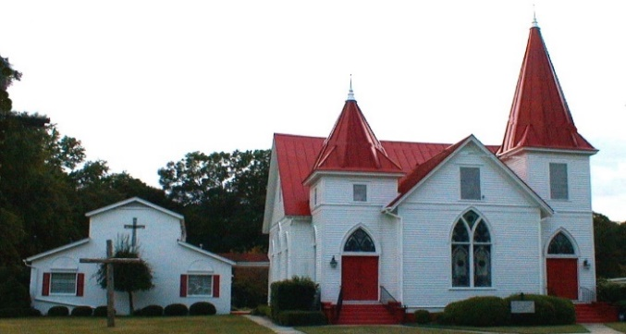 |  APRIL 2022
Sun. | Mon. | Tue. | Wed. | Thu. | Fri. | Sat.
 |  |  |  |  | 1. | 2
 |  |  |  |  |  | A.J Collier
3 S.S. 10 a.m. | 4 | 5 | 6 | 7 | 8 | 9
Worship 11am Online option  Soup & small group making palm crosses  Emma Felker |  | Centering Prayer 8:30 a.m. |  |  | Tommy & Wendi Martin
10 Palm Sunday | 11 | 12 | 13 | 14 | 15 | 16
S.S. 10 a.m.  Worship 11am  Online option  Will Haigler | MUMC Holy week noon Lunch PB preaches | Centering Prayer 8:30 a.m.  MUMC Holy week noon Lunch | MUMC Holy week noon Lunch | Maundy Thursday 6:30p | Good Friday 6:30 pm | Easter Vigil Bonfire MZSL carport 7:30-8:30 pm  Maggie Rodgers Allotton
17 Easter Sunday | 18 | 19 | 20 | 21 | 22 | 23
Sunrise Service Oglethorpe Cemetery 7a.m. Breakfast at MZSL to follow.  No S.S  Worship at 11:00 a.m Online option  Newsletter Deadline |  | No Centering Prayer  Renee Maddox Collier | Pastor Barb on vacation | Jon & Karen Coogle |  | Ava Felker
24 | 25 | 26 | 27 | 28 | 29 | 30
School 10:00 a.m.  Worship 11:00 a.m.  Online option available  . | Pastor Barb on vacation | Centering Prayer 8:30 a. |  | Sara Morgan Martin  Katie Gentile |  | Highway Clean-up Mt. Zion Cemetry 9am

