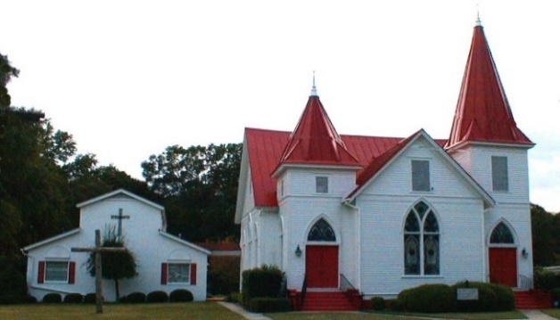

August 2021
Sun. | Mon. | Tue. | Wed. | Thu. | Fri. | Sat.
1  S.S.10 a.m.  Worship 11a.m.  Online option | 2 | 3  Centering Prayer  8:30 a.m | 4  Soup Kitchen at Noon  Bible Study 7:00p | 5 | 6 | 7  Tony & Renee Collier
8  Council Meeting 8:45a.m.  S.S.10 a.m.  Worship 11a.m.  Online option | 9  Jeremy & Susan Martin | 10  Centering Prayer  8:30 a.m. | 11  Bible Study 7:00p  David & Mary Haigler | 12  Shane Peaster | 13 | 14
15  S.S.10 a.m.  Worship 11a.m.  Online option | 16 | 17  Centering Prayer  8:30 a.m. | 18  Bible Study 7:00p | 19 | 20 | 21  Jim Trask
22  S.S.10 a.m.  Worship 11a.m.  Online option  Family Day Dinner to follow  Newsletter Deadline | 23  Jennifer Kleckley | 24  Centering Prayer  8:30 a.m. | 25  The Oaks 10:30 am  Bible Study 7:00p | 26  Tommy Coogle | 27 | 28
29  S.S.10 a.m.  Worship 11a.m.  Online option  Rainey Elizabeth Collier | 30 | 31  Centering Prayer  8:30 a.m.  Zach Martin

