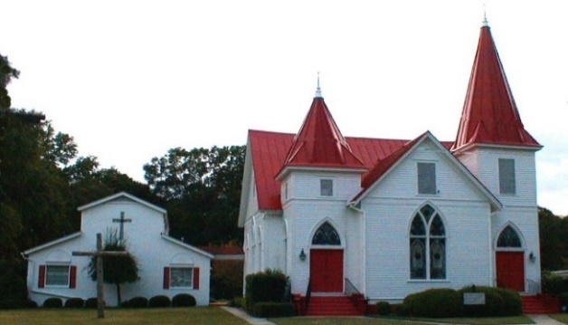

Dec. 2021
Sun. | Mon. | Tue. | Wed. | Thru | Fri. | Sat.
 |  |  | 1.  Advent activity 6: 30 pm | 2. | 3. | 4.
5.  S.S 10 a.m.  Worship 11 am  Online Option | 6. | 7.  Centering Prayer 8:30 am  Drive – thru Foster Children Party 5:45 pm | 8.  Advent activity 6: 30 pm | 9. | 10. | 11.
12.  S.S 10 a.m.  Worship 11 am  Annual Congregation Meeting follows  Online Option | 13. | 14.  Centering Prayer 8:30 am | 15.  The Oaks 10:30 a.m  Advent activity 6: 30 pm | 16. | 17. | 18.
19. Council meeting  S.S 10 a.m.  Worship 11 a.m. Foster Fundraiser Meal Confirmation following meal  Online Option  Newsletter Deadline | 20. | 21.  Centering Prayer 8:30 am | 22.  Advent activity 6: 30 pm | 23. | 24.  Christmas Eve service 7 p.m. | 25.  MERRY CHRISTMAS!!
26.  S.S 10 a.m.  Lessons and Carols 11am  Online Option | 27.  Lingle Room reserved | 28.  Centering Prayer 8:30 am | 29.  Bible Study 6 p.m. | 30. | 31.

