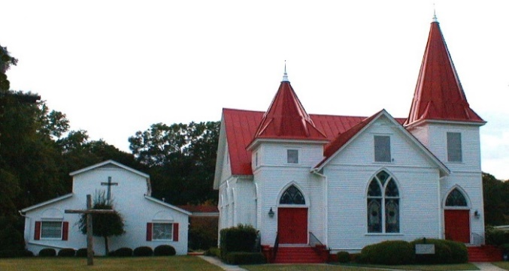 |  February 2021
Sun. | Mon. | Tue. | Wed. | Thu. | Fri. | Sat.
 | 1 | 2 | 3 | 4 | 5 | 6
 |  |  |  | Grady English
7 | 8 | 9 | 10 | 11 | 12 | 13
Worship 11:00 a.m.  Online Only | Wendi Martin | Centering Prayer 8:30 a.m. | Bible Study 6:00 p.m. Lingle Room | Bobby Martin
14 | 15 | 16 | 17 | 18 | 19 | 20
Worship 11:00 a.m.  Online Only  Valentine’s Day |  | Centering Prayer 8:30 a.m.  Al Coogle, Sr | Ash Wednesday  Online Worship Service 6:00 p.m.  Bible Study 6:00 p.m. | Grady & Patsy English
21 | 22 | 23 | 24 | 25 | 26 | 27
Lent 1 Morning Worship 11:00 a.m. Online Only  Newsletter Deadline |  | Centering Prayer  8:30 a.m.  Grady & Patsy English | Lent 1 Evening Online Prayer Service |  | Glenn Brannan
28 |  |  |  | 27 | 28 | 29
Lent 2 Morning Worship 11:00 a.m. Online Only

