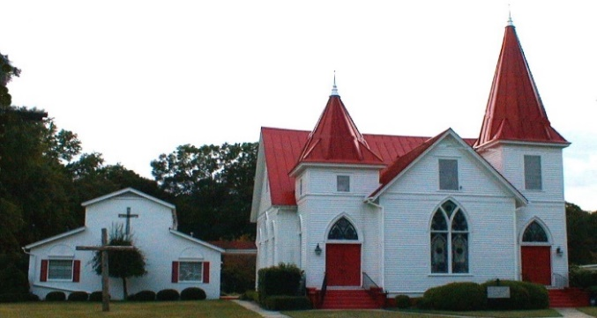 |  January 2021
Sun. | Mon. | Tue. | Wed. | Thu. | Fri. | Sat.
 |  |  |  |  | 1 | 2
 |  |  |  |  |  | D.C. Williams
3 Epiphany | 4 | 5 | 6 | 7 | 8 | 9
Observed  Worship 11 a.m.  Installation of New Council Members  Election of officers  After service- brief |  | Centering Prayer 8:30 a.m. | New Bible Study Begins 6:00 pm |  |  | Angie Collier
10 | 11 | 12 | 13 | 14 | 15 | 16
Worship 11 a.m.  Council Meeting 9:30 a.m. |  | Centering Prayer  8:30 a.m.  DC Williams &  Bill Williams | Bible Study 6:00p.m.
17 | 18 | 19 | 20 | 21 | 22 | 23
Worship 11 a.m.  Newsletter Deadline |  | Centering Prayer 8:30 a.m.  Jenny Brannon  Aiden Coogle | Bible Study 6:00p.m. |  | Lelan Moretz | Angie Summer
24 | 25 | 26 | 27 | 28 | 29 | 30
Worship 11 a.m. |  | Centering Prayer 8:30 a.m. | Bible Study 6:00p.m.  Freddy Virden |  | Richard Collier | Gulshanprem & Neelima Choppla  Myrtle Joiner
31

Worship 11 a.m.

Max Wood

Serving Our Lord in January

Ushers Brenden Fitzgerald and Ted Robinson
Altar Guild Joe & Joy McNutt and Tommy Martin
Lectors Jon Coogle and Wendi Martin

Family Day: No Family Day Meal until further notice.

Coffee Hour: No Coffee Hour until further notice.

Flowers:

1-03 Poinsettias for Epiphany

1-10 Jim and Patricia Trask in loving memory of John and Sarah Trask

1-17 Jimmy and Mary Kay Watson in honor of Daniel

1-24 Grady and Patsy English in loving memory of Miss Ruth Kleckley

1-31 David and Mary Haigler in honor of Will and Katie

Soup Kitchen: No Soup Kitchen until further notice.

Sunday School: No Sunday School until further notice.

January Birthdays and Anniversaries
1-02 DC Williams 1-23 Angela (Angie) Summer
1-09 Angie Collier 1-27 Freddy Virden
1-12 DC & Bill Williams 1-29 Richard Collier
1-19 Jenny Brannan 1-30 Gulshan Prem &Neelima Choppla
1-19 Aiden Coogle 1-30 Myrtle Joiner
1-22 Lelan Moretz 1-31 Max Wood

