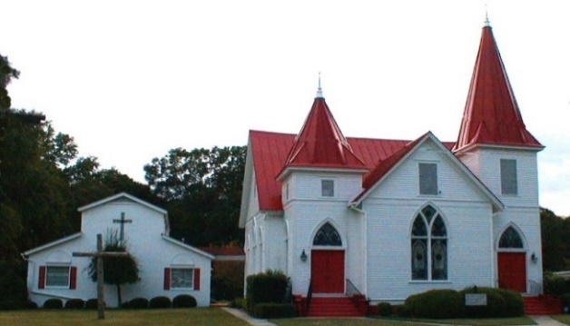

June 2021
Sun. | Mon. | Tue. | Wed. | Thu. | Fri. | Sat.
 |  | 1  Centering Prayer  8:30 a.m. | 2  Soup Kitchen noon  Bible Study 7:00p  Tommy & Gail Coogle | 3  Ginny Martin | 4 | 5
6  S.S.10 a.m.  Worship 11a.m.  Online option  Duck & Pastor Barb Koch | 7 | 8  Centering Prayer  8:30 a.m. | 9  Bible Study 7:00 p  Diane Coogle | 10 | 11  Billy & Ginny Martin | 12
13 Council 8:45  S.S.10 a.m.  Worship 11a.m.  Online option  Pastor Barb on Vacation  Blake Coogle | 14 | 15 | 16 | 17 | 18 | 19  Mary Virden
20  Happy Father’s Day!  S.S.10 a.m.  Worship 11a.m.  Online option  Billy Martin | 21 | 22  Centering Prayer  8:30 a.m.  Julia Snipes | 23  Bible Study 7:00p | 24 | 25 | 26
27  S.S.10 a.m.  Worship 11a.m.  Online option  Mary Jane Ethridge | 28 | 29  Centering Prayer  8:30 a.m. | 30  The Oaks  10:30 a.m.  Bible Study 7:00 p

