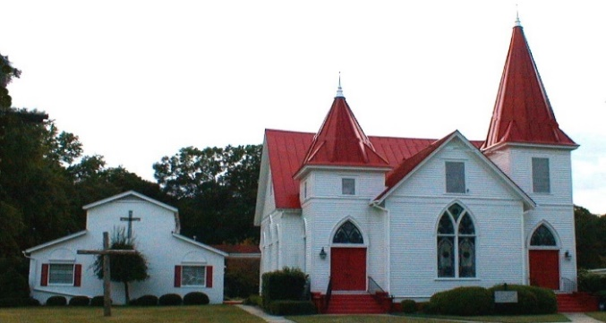 |  March 2021
Sun. | Mon. | Tue. | Wed. | Thu. | Fri. | Sat.
 | 1 | 2 | 3 | 4 | 5 | 6
 | Daniel Watson | No Centering prayer. PB will be out of town.  Jimmy Watson | Lenten Service 6:00 p.m. Online  April Martin
7 | 8 | 9 | 10 | 11 | 12 | 13
Worship 11:00 a.m.  Online Only |  | Centering Prayer 8:30 a.m. | Lenten Service 6:00 p.m. Online
14 | 15 | 16 | 17 | 18 | 19 | 20
Council Meeting at 9:30 a.m.  Worship 11:00 a.m. Online Only  Winn Martin |  | Centering Prayer 8:30 a.m. | Lenten Service 6:00 p.m. Online | Phillip & Carla Stuckey
21 | 22 | 23 | 24 | 25 | 26 | 27
Worship 11:00 a.m. Online Only  Newsletter Deadline |  | Centering Prayer  8:30 a.m.  Patsy English | Lenten Service 6:00 p.m. Online |  |  | Landon Martin
28 | 29 | 30 | 31 | 1 | 2
Worship 11:00 a.m. Online Only | Jamey Cannon  Jimmy & Mary Kay Watson | Jamey & Angela Cannon | Ivy Moretz Cazier | Maundy Thursday TBA | Good Friday

Serving Our Lord in March

Ushers Jamey Cannon and Tommy Coogle
Altar Guild Gail Coogle and Duck Koch
Lectors Karen Coogle and Mary Kay Watson

Family Day: No Family Day Meal until further notice.

Coffee Hour: No Coffee Hour until further notice.

Flowers:

3-07 Jim and Patricia Trask in honor of their children and grandchildren.

3-14 Ann Coogle and Sara H Dawson in loving memory of Annette Coogle and
Ed Coogle; Ed Coogle, Jr.

3-21 Jon and Karen Coogle in memory of Barbara and Bill Scovill.

3-28 Joy and Joseph McNutt in memory of Joe’s grandmother, Ruth Shields.

Soup Kitchen: No Soup Kitchen until further notice.

Sunday School: No Sunday School until further notice.

March Birthdays and Anniversaries
3-01 Daniel Watson 3-27 Landon Martin
3-02 Jimmy Watson 3-29 Jamey Cannon
3-03 April Martin 3-29 Jimmy & Mary Kay Watson
3-14 Winn Martin 3-30 Jamey & Angela Cannon
3-18 Phillip & Carla Stuckey 3-31 Ivy Moretz Cazier
3-23 Patsy English

