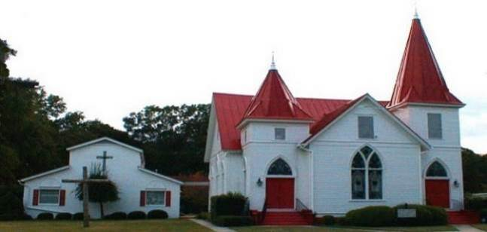

**Good News**

***Lead Us, Lord…***

When we lived near Savannah, our landlord had a large

pasture right next to our house, and he graciously allowed

us to realize one of our dreams. We brought home a young

donkey, newly weaned from his mother, and made him our

own. For the first month, Hotay (as in Donkey Hotay) was

cooped up in a little pen off our landlord’s barn while we worked with him, slowly earning his trust, and teaching him that, now, *we* were his “herd”. After much patient work on Duck’s part, Hotay had learned to follow a lead. He had learned that bucking and twisting and resisting the rope got him nowhere, while walking nicely beside Duck earned him a tasty treat. And, when the walk was over, he returned to his pen without a fight. It was time for him to be let out to pasture.

I remember well the day of the big test. We didn’t know what would happen when we let Hotay off the lead. Would we be able to get him back on again? Would he allow us to return him to his pen for the night? Or would we end up chasing him all over the pasture, trying to corner him in the field? It was time to find out. Carefully, Duck unhooked the lead rope from the halter. We stepped back and waited.

It took a minute for Hotay to realize that there was nothing holding him back. But, when he did, look out! He jumped straight up in the air, kicked up his heels, and was off and running! Straight across the pasture he ran at a full gallop, head thrown back, full of spirit, wind in his face! Back and forth, up and down the fence line he ran, savoring his freedom. And, we couldn’t help but laugh ourselves! His joy was contagious! But, we kept our eyes on him all the time to be sure he didn’t get into trouble. We needn’t have worried. When he ran himself out, Hotay trotted calmly back to where we were standing so we could rub his head, and scratch his chin, and hug his neck. We knew then that the bond between us had been set, and it felt good.

Looking back at that day, I got to thinking about the bond between us and our God. Aren’t we sort of like that donkey? Hasn’t God chosen us for his own? Hasn’t God had to work and work with us to slowly build up trust? Haven’t we resisted at times, not wanting to follow, but bucking and twisting and resisting his lead? “Do not be like a horse or a mule, without understanding, whose temper must be curbed with bit and bridle, else it will not stay near you.” says Psalm 32:9. What a pleasure it must be for God to watch us kick up our heels, running free, full of Spirit, savoring the freedom we find only in him. How good it must feel, when we return to God of our own free will, to let him hug our necks.

During this Lenten season, may the bond between us and God become stronger and our trust in him become deeper. May we more readily take instruction, with less resistance and less desire to go our own way. May we find comfort in knowing that the Lord will lead us in right paths, keeping his eye on us all the while. And, may we always *joyfully* return to the Lord our God, for he is gracious and merciful, slow to anger, and abounding in steadfast love.

***Looking forward to walking with you on our Lenten journey,*****Pastor Barb** <><

***I will instruct you and teach you the way you should go;***

***I will counsel you with my eye upon you. Psalm 32:8***

**Mt Zion – St Luke Lutheran**

***March 2020***

**March 2020**

**3-1** SS10a/Worship 11a.

***Soup & Small Group - noon***

**3-2** Grace Circle 10:00 a.m

**3-3** Centering Prayer 8:30

**3-4** Soup Kitchen Noon

Bible Study 6:00 p.m.

**3-8** **Daylight Savings Time**

Council Mtg 8:45 a.m.

SS10a/Worship 11a.

***Soup & Small Group - noon***

**3-10** Centering Prayer 8:30 a.

Quilting 10:00 a.m.

**3-11** Bible Study 7:00 p.m

*(new time – Daylight Savings)*

**3-15** SS10a/Worship 11a

***Soup & Small Group- noon***

***Newsletter Deadline***

**3-17** Centering Prayer 8:30

**3-18** Oaks Nursing Home 10:30 a.m.

Bible Study 7:00p

*(new time – Daylight Savings)*

**3-21 Conference #2 Meets**

**Kennesaw – 1st United**

**Lutheran: 9a-2p**

*Block Party* 4-7 p.m. in front

of Courthouse in Oglethorpe

**3-22** SS10a/Worship 11a a.m.

***Soup & Small Group - noon***

**3-24** Centering Prayer 8:30a

**3-25** Bible Study 7:00 p.m.

*(new time – Daylight Savings)*

**3-29** SS10a/Worship 11a

***Soup & Small Group - noon***

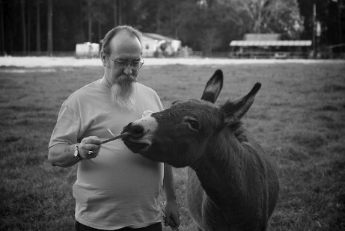

**Serving Our Lord in March**

**Communion Assistant** April Martin

**Ushers** Jamey Cannon and Tommy Coogle

**Altar Guild** Gail Coogle and Duck Koch

**Lectors** Karen Coogle and Mary Kay Watson

**Kyrie** Tommy Martin

**Acolytes:** Dolcie Choppla

**3-15 Family Day replaced by Soup and Small Group – 40 Days of Prayer**

**Coffee Hour:**

3-1 Mary Jane Ethridge 3-8 Jon Coogle 3-15 Brenden Fitzgerald

3-22 Karen Hatten 3-29 Angela Cannon

**Flowers:**

**3-1** Mary Hammock in loving memory of her parents and in remembrance of

special people in her life.

**3-8** Ann Coogle and Sara H Dawson in loving memory of Annette Coogle and

Ed Coogle; Ed Coogle, Jr.

**3-15** Jon and Karen Coogle in memory of Barbara and Bill Scovill.

**3-22** Jim and Patricia Trask in honor of their children and grandchildren.

**3-29** Joy and Joseph McNutt in memory of Joe’s grandmother, Ruth Shields.

**Soup Kitchen:** Gail Coogle

**Sunday School Teachers:**

**K-5th Grade** – Angela Cannon **6th – 12th Grade** – Renee Collier

**Adult Class Lingle Room** – David Haigler/Jon Coogle

**Adult Class** *Conference Room* – Wendi Martin

**March Birthdays and Anniversaries**

3-1 Daniel Watson 3-23 Patsy English

3-2 Jimmy Watson 3-27 Landon Martin

3-3 April Martin 3-29 Jamey Cannon

3-9 Arthur Jackson 3-29 Jimmy & Mary Kay Watson

3-14 Winn Martin 3-30 Jamey & Angela Cannon

3-18 Phillip & Carla Stuckey 3-31 Ivy Moretz Cazier

**You Can’t Out Give God!**

That is a profound statement requiring little explanation to a Christian. God, the creator of all life, gave his only Son to show us how to live our life with generosity.

We are entering the season of Lent; a time of reflection, contemplation and prayer. Rather than give something *up,* I would ask you to *do* something. Make it a daily practice to *pray.* Talk to God every day. Nothing elaborate is required. No specific place is needed. They can be prayers of gratitude, prayers for the needs of others, or guidance.

Some ideas for you even as you are reading this: pray for those who are sick or suffering, pray for our pastor, pray for farmers and owners of small businesses, pray for nurses and doctors, pray for our country and our freedom, pray for the children getting off the bus, pray with a joyful heart for each new day. Pray to be a better steward of your time and money. And remember to pray for our church and other churches who are struggling with the same issues we have. Dear God, thank you for loving us! Amen! *Julia Snipes, Stewardship*

**Gift Bags for Soup Kitchen**

Grace Circle is asking for your help. We would like to provide gift bags of toiletries to the people who come to eat at the Soup Kitchen. We plan to give the bags out on the first Wednesday in April, just prior to Easter. Items that we need are sample size **soap, body lotion, deodorant, toothpaste, toothbrush, hand sanitizer, and shampoo.** We will be making bags for men and women. We will have baskets in the narthex for your items. Thanks for helping us to help others! *Grace Circle*

**Soup and Small Group**

During Lent, our Vitality Leadership Team will guide us in our efforts to hear what God might be saying to MZSL through a devotion called **40 Days of Prayer**. Each of us will be assigned a small group. Each of us will pray briefly every day from Monday through Saturday on our own using the guided prayer handout we each have received, writing down a word or a phrase we hear from listening to God in our prayer each day. Then, on Sunday, we will all gather in the Lingle Room for a simple soup meal. After eating, we will meet in our small groups and *Listen to each other,* sharing the insights and making short notes of common themes heard in our individual prayers. Each group will place the notes on the bulletin boards of what they have heard. We will do this for the 5 Sundays in the Lenten cycle: March 1, 8, 15, 22 and 29. After the 40 days of prayer, we will gather together as a congregation and discuss the themes that arose from our small group meetings, arriving at 3-5 ways God may be calling us as a church to participate more fully in God’s mission to save the world. We will then begin the *third* Listening – *Listening to our neighbors,* to see where we might meet a need in our community and tell the story of Jesus while doing it! Thank you for being willing to faithfully participate in this important Lenten discipline! *Pastor Barb and your Congregation Vitality Team.*

**Mark Your Calendar for March 21, 2020 – Annual Conference #2 Meeting** This year’s Conference #2 –“The Good News Conference” will be held at First United Lutheran Church in Kennesaw from 9 a.m. to 2;00 p.m. It is a long way to go, but a most important yearly event in which the congregations in Georgia of our synod get together to get to know one another better, learn how we can support each other and to be reminded that we are part of something much bigger than ourselves. I look forward to this event every year, and encourage you to attend as well. Let’s have a good showing for MZSL!

**Looking Ahead - Holy Week Schedule for 2020 is as follows:**

**Palm Sunday, April 5th:** Blessing of the Palms and procession into the sanctuary.

**Maundy Thursday,** **April 9th:** Holy Communion and Stripping of the Altar - 7:00 p.m.

**Good Friday**, **April 10th:** Service of Solemnity at 7:00 p.m.

**Easter Sunday, April 12th:** Joint Easter Sunrise Service led by Oglethorpe UMC -Oglethorpe Cemetery: 7 ish; Breakfast to follow at Oglethorpe UMC.

Easter Celebration Service at MZSL at 11:00 a.m.

**INSTALLATION of 2020 CONGREGATION COUNCIL**

**COUNCIL MEMBERS for 2020**

**Angela Cannon, Jon Coogle, Katie Felker, Karen Hatten, Arthur Jackson,**

**Wendi Martin, Joseph McNutt and Max Wood**

**Mt. Zion – St. Luke Lutheran Church**

**P.O. Box 187**

**401 Randolph Street**

**Oglethorpe, Georgia 31068**

ooxWord://word/media/image170.pngooxWord://word/media/image171.pngooxWord://word/media/image172.pngooxWord://word/media/image174.pngooxWord://word/media/image175.pngooxWord://word/media/image176.pngooxWord://word/media/image177.pngooxWord://word/media/image178.pngooxWord://word/media/image179.pngooxWord://word/media/image180.pngooxWord://word/media/image181.pngooxWord://word/media/image182.pngooxWord://word/media/image183.pngooxWord://word/media/image184.pngooxWord://word/media/image185.pngooxWord://word/media/image186.pngooxWord://word/media/image187.pngooxWord://word/media/image188.pngooxWord://word/media/image189.pngooxWord://word/media/image190.pngooxWord://word/media/image191.pngooxWord://word/media/image192.pngooxWord://word/media/image193.pngooxWord://word/media/image194.png



**Prayer List**

**New Bible Study Opportunities That You Won’t Want to Miss!**

Wendi Martin invites you to join her Sunday Morning Bible Study class as they study the book by Max Lucado

called *Jesus, the God Who Knows Your Name*. Lucado writes in hopes that you come to the “heart-stopping realization that in Him you are a part of something that is ancient, endless, unstoppable and unfathomable.”

The class starts at 10:00 am. in the Conference Room next to the church office.

The Wednesday evening Bible Study led by Pastor Barb is beginning a new series on

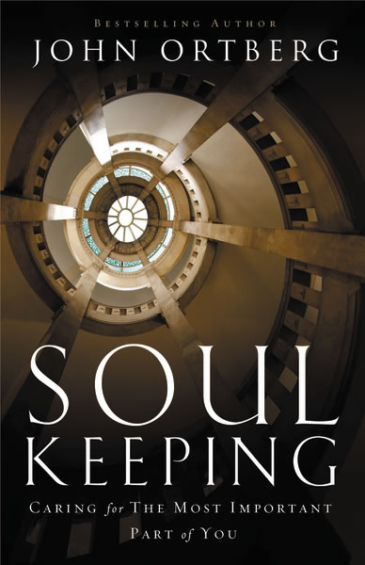

March 4th called *Soul Keeping*. Author John Ortberg says “The soul is the coolest,

eeriest, most mysterious, evocative, crucial, sacred, eternal life-directing, fragile,

indestructible, controversial, expensive dimension of your existence. Jesus said it’s worth

more than the world. You’d be an idiot not to prize it above all else. Shouldn’t you get

pretty clear on exactly what it is?” Come, join us Wednesday evenings at 6:00 p.m. (7:00p when Daylight Savings begins on 3-8) in the Lingle Room as we learn more about

our own soul and how to take good care of it!

***Please Pray******for Members****:* Jim Arnold, Al Coogle, Brenden Fitzgerald, Jr, Mary Hammock, Emily Harvill, Zack Martin, Joe McNutt, Tricia Trask, Tony Webb, for our college students, for all the ministries of our church and for our Military.

***For Friends and Family***: Langdon Harp, Peggy Harvey, Janice Haugabook, Ricky Haugabook, Larry Hobbes, Elizabeth Homer, Curtis Johnson, Corby McClure; Bob Melvin; Crystal Miller, Buddy Murph, Charlene Oliver, Leigh Powel, Douglas Smith, Celeste Trilla, and Joanne Waymon.

|  |  |
| --- | --- |
| ***Serving Our Nation****:* John Edwards |  |

*Serving Our Nation*: John Edwards