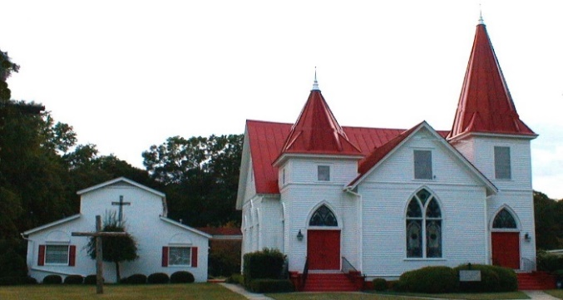 |  MAY 2021
Sun. | Mon. | Tue. | Wed. | Thu. | Fri. | Sat.
1
Clean up session 9 am
2 | 3 | 4 | 5 | 6 | 7 | 8
Wendi’s Sunday School 10:00 a.m.  Worship at 11:00  Online option available  Dale Godfrey | Tracy Choppla | Centering Prayer  8:30 a.m. | Bible Study 6:00 p.m.
9 | 10 | 11 | 12 | 13 | 14 | 15
Council Meeting at 9:00 a.m.  Wendi’s Sunday School 10:00 a.m.  Worship 11:00  Online option available |  | Centering Prayer  8:30 a.m. | Bible Study 6:00 p.m. | Trey & Laura Coogle
16 | 17 | 18 | 19 | 20 | 21 | 22
Wendi’s Sunday School 10:00 a.m.  Worship 11:00  Online option available  Family Dinner | Katie Felker  Laney Martin | Centering Prayer  8:30 a.m. | Bible Study 6:00 p.m. |  |  | Susan Martin
23 | 24 | 25 | 26 | 27 | 28 | 29
Wendi’s Sunday School 10:00 a.m.  Worship 11:00  Online option available |  | Centering Prayer  8:30 a.m. | Bible Study 6:00 p.m.
30  Wendi’s Sunday School 10:00 a.m.  Worship 11:00  Online option available | 31

