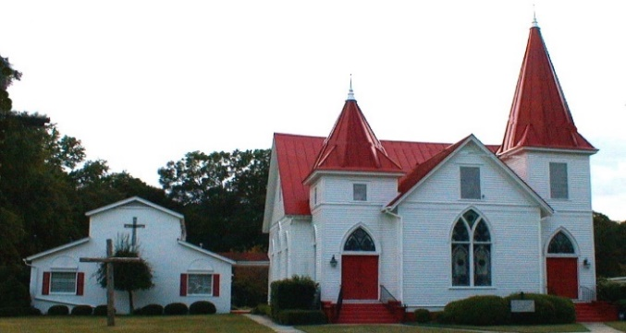 |  MAY 2022
Sun. | Mon. | Tue. | Wed. | Thu. | Fri. | Sat.
1.  Sunday School 10:00 a.m.  Worship at 11:00  Online option available | 2  Dale Godfrey | 3  Centering prayer 8:30 a.m.  Tracy Choppla | 4  Bible Study 7:00 p.m. | 5 | 6 | 7
8 | 9 | 10 | 11 | 12 | 13 | 14
Sunday School 10:00 a.m.  Worship at 11:00  Online option available |  | Centering Prayer  8:30 a.m. | Bible Study 7:00 p.m. |  | Trey & Laura Coogle
15 | 15 | 17 | 18 | 19 | 20 | 21
Sunday School 10:00 a.m.  Worship 11:00  Small group followed |  | Centering Prayer  8:30 a.m.  Katie Felker  Laney Martin | The Oaks 10:30 a.m.  Bible Study 7:00 p.m.
22 | 23 | 24 | 25 | 26 | 27 | 28
Sunday School 10:00 a.m.  Worship (Rev. Hemphill) 11:00 a  Family Dinner  \  Susan Martin |  | Centering Prayer  8:30 a.m. | Bible Study 7:00 p.m.
29 | 30 | 31
Sunday School 10:00 a.m.  Worship 11:00  Online option available |  | Centering Prayer  8:30 a.m.
30  Sunday School 10:00 a.m.  Worship 11:00  Online option available | 31

