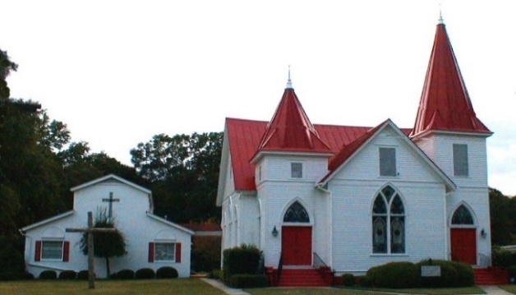

Nov. 2021
Sun. | Mon. | Tue. | Wed. | Thru | Fri. | Sat.
 | 1. | 2.  Centering Prayer 8:30 am  VOTE!!! | 3.  No Soup Kitchen  Bible Study 7p | 4. | 5. | 6.
7.  S.S 10 a.m.  Worship 11 am | 8. | 9.  Centering Prayer 8:30 am | 10  Bible Study 6p | 11. | 12 | 13
14.  Council 8:45 a.m.  S.S 10 a.m.  Worship 11 am | 15  Pastor on vacation | 16.  No Centering Prayer | 17.  No Bible Study | 18 | 19. | 20
21.  S.S 10 a.m.  Worship 11 a.m. Family Day Meal  Newsletter Deadline | 22. | 23.  Centering Prayer 8:30 am | 24.  Bible Study 6p | 25.  Lingle room Reserved | 26. | 27.
28.  S.S 10 a.m.  Worship 11 a.m.  Online option | 29. | 30.  Centering Prayer 8:30 am

