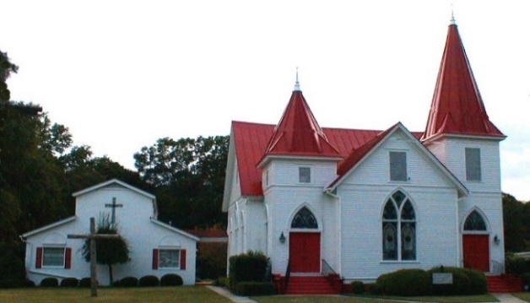

Oct 2021
Sun. | Mon. | Tue. | Wed. | Thru | Fri. | Sat.
 |  |  |  |  | 1. | 2.
3.  Wendi’s class online at 9a  S.S 10 a.m.  Worship 11 am  Blessing of the Animals 5pm | 4. | 5.  Centering Prayer 8:30 am | 6.  No Soup Kitchen  Bible Study 7p  Renee Collier | 7.  Daniel Coogle  Jeremy Martin | 8. | 9.  Neelima Oguri
10. In Person  Council Meeting at 8:45 a.m.  Wendi’s class online at 9a  S.S 10 a.m.  Worship 11 am  George & Helen Smith |  | 12.  Centering Prayer 8:30 am  George Coogle | 13.  Bible Study 7p  Tricia Trask | 14. | 15. | 16.
17.  Wendi’s class online at 9a  S.S 10 a.m.  Worship 11 a.m.  Newsletter Deadline  George Smith | 18.  Ava Coogle  Brenden Fitzgerald | 19.  Centering Prayer 8:30 am | 20.  Bible Study 7p | 21. | 22. | 23.
24.  Wendi’s class online at 9a  S.S 10 a.m.  Worship 11 a.m.  Online option | 25.  Callie Ann Coogle  Emily Harvill | 26.  Centering Prayer 8:30 am  Franchelle Arnold | 27.  Bible Study 7p | 28.  Karen Hatten | 29.  Billy Martin | 30.  Adopt-A-Highway littler pickup at 9am
31.
Wendi’s class online at 9a
S.S 10 a.m.
Worship 11 a.m.
Reformation/Rally Day after church

